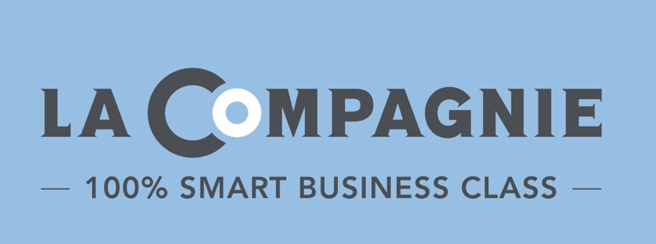
PRESS RELEASE
Coronavirus COVID-19 :
Tuesday, October 19, 2021

100% Smart Business Class Airline La Compagnie
Announces Updated Flight Program for End of 2021 and 2022

Following the recent announcement of vaccinated travelers being able to enter the U.S. on November 8 and with Israel also planning to reopen its boarders this Fall, La Compagnie is ramping up service for the end of 2021 and looking ahead to 2022 with an updated schedule of all business-class flights from New York to Paris, Tel Aviv, Milan and Nice.

2021-2022 FLIGHT PROGRAM

New York (EWR) to Paris (ORY) − FROM $2,000 R/T
Since the opening of European borders in June, La Compagnie has resumed its activity between New York and Paris at a rate of four to five flights per week. The latest announcements from the US government will allow the airline to resume daily service starting November 2021 offering travelers more choices and flexibility at the most attractive fare.

New York (EWR) to Tel Aviv (TLV) − DECEMBER 4, 2021
Given the success of its business model and the performance of its two new Airbus A321neos, La Compagnie announced its ambitions to launch a new route between New York and Tel Aviv this summer which was postponed due to extended travel restrictions by the State of Israel. This route will finally see the light of day starting December 4, 2021, with two flights per week between Newark International Airport (EWR) and Ben Gurion Airport (TLV) with a 1h30 stop in Paris.

New York (EWR) to Milan (MXP) − APRIL 13, 2022
Starting April 13, 2022, La Compagnie will expand its European offering with direct service between New York and the Fashion Capital of the World, Milan with four flights per week from Newark International Airport (EWR) to Milan Malpensa Airport (MXP).

New York (EWR) to Nice (NCE) − MAY 7, 2022
In addition to the 2022 program, seasonal service between New York and Nice will resume on May 7, 2022, with three weekly flights operating until September 27, 2022. This route, which successfully launched in 2019, provides travelers direct access to the South of France during prime season.

“The recent announcement from the U.S. government gives us better visibility on the resumption of activity. The entire team at La Compagnie is prepared and ready to fully tackle this rich program that we have been keen to put in place for the past few months. Utilizing the full capacity of our devices by broadening our horizons is not only essential but relevant when it comes to meeting the expected surge in demand from both the leisure and business markets,” shared Christian Vernet, President of La Compagnie.

To help customers plan their trips with complete peace of mind, all La Compagnie tickets are now bookable at 100% Flex − changeable and refundable at no cost− up to 24H before departure. Special promotional deals are also available now through December 31, 2021, with round-trip fares between New York and Paris and New York to Tel Aviv starting at $2,000. Travel dates are subject to availability and all taxes and carrier-imposed fees are included in the fare. La Compagnie authorizes two checked bags per passenger free of charge; baggage fees apply for any additional bags.

For reservations on La Compagnie, visit LaCompagnie.com, call the airline’s call center at 1-800-218-6820, or contact your preferred travel advisor.

***

About La Compagnie
Launched in July 2014, La Compagnie is an exclusively 100% Smart Business Class airline operating regularly scheduled transatlantic flights between New York (Newark International Airport) and Paris (Paris Orly Airport) and seasonal service between New York (Newark International Airport) and Nice (Nice Côte d'Azur International Airport) as well as flights to Tel Aviv (Ben Gurion Airport) and to Milan (Milan Malpensa Airport). Offering competitively low business-class fares, La Compagnie Airbus A321neo fleet is fitted with 76 full-flat seats and provides thoughtful amenities including a state-of-the-art entertainment system, unlimited Wi-Fi service and a unique dining experience offering fresh menu items by renowned New York and Paris based chefs. For reservations, visit lacompagnie.com, call the airline's call center at 1-800-218-8187 or contact your travel advisor.

Press Contact
Anne-Cecile Blanchot
August Twenty Eight
annececile@august28studio.com

