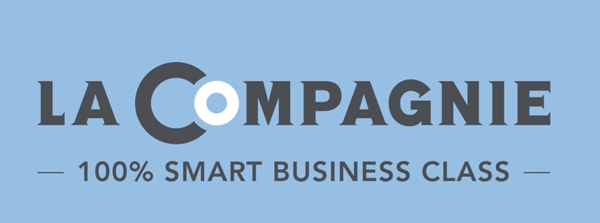
PRESS RELEASE
Coronavirus COVID-19 :
January 25, 2022

La Compagnie offers special duo fares and brings together lovers from across the pond for Valentine’s Day!

This Valentine’s Day, 100% smart business class airline La Compagnie is embracing the power of love with ‘Duo’ promotional fares to Paris, Nice, and Milan from February 1 to 14. Plus, it’s taking the holiday one step further by offering to reunite couples from both sides of the Atlantic with a special contest running all week long.

Duo deals for a romantic escape
Nothing says I love you like a trip to the City of Love, the South of France, or the Fashion Capital of the World! From Tuesday, February 1 to Monday, February 14, 2022 included, travelers and lovers will be able to enjoy incredible deals on more than 2000 business class tickets to Paris (ongoing), Nice (resuming May 7) and Milan (launching April 15) for flights departing from New York until the end of the year*.

- Fly NYC to PARIS in business-class for $3,000 round-trip for two
- Fly NYC to NICE in business-class for $3,000 round-trip for two
- Fly NYC to MILAN in business-class for $2,800 round-trip for two

* Based on availability. All tickets are changeable without fees; tickets are nonrefundable.

A contest to celebrate love from a distance
This week only, La Compagnie is running an exclusive “Long Distance Relationtrip” contest on its Instagram and Facebook channels. To participate, couples in a long distance relationship between Paris and New York are encouraged to follow the airline on social media, like the dedicated post, and tag their loved one in the comment section; sharing the post will grant them an additional entry. Two lucky couples will be chosen, and the New York based winners will receive a round-trip ticket allowing them to travel to Paris to reunite with their significant others over an extended Valentine’s Day weekend, from February 10 to 15, 2022. Results will be announced next Monday, January 31.

For more information, visit lacompagnie.com.

***

About La Compagnie
Launched in July 2014, La Compagnie is an exclusively business-class airline operating regularly scheduled transatlantic flights between New York (Newark International Airport) and Paris (Paris Orly Airport) and seasonal service between New York (Newark International Airport) and Nice (Nice Côte d'Azur International Airport). Offering competitively low business-class fares, La Compagnie is outfitted with 76 full-flat seats and provides thoughtful amenities including a state-of-the-art entertainment system, unlimited Wi-Fi service and a unique dining experience offering fresh menu items by renowned New York and Paris based chefs. For reservations, visit lacompagnie.com, call the airline's call center at 1-800-218-8187 or contact your travel advisor.

Press Contact
Jennifer Reich, August Twenty Eight
jennifer@august28studio.com

