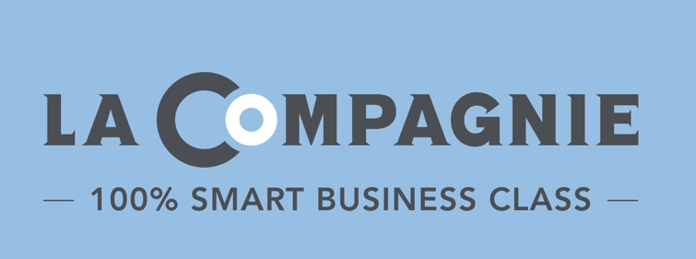
PRESS RELEASE
Coronavirus COVID-19 :
Friday, November 19, 2021

LA COMPAGNIE BUSINESS-CLASS AIRLINE BRINGS BACK “BLUE FRIDAY” PROMOTION WITH $1,500 R/T FLIGHTS ON ITS NEWEST ROUTE

Blue Friday returns November 19-23,2021 with an unparalleled offer on La Compagnie’s new New York-Milan route, scheduled to take off next Spring

Smart business-class airline La Compagnie is pleased to bring back its “Blue Friday” promotion with unbeatable fares to Milan in celebration of the route launching next Spring. Live Friday, November 19 through Tuesday, November 23, 2021, travelers will be able to book direct, round-trip business class flights to Italy for just $1,500.

After a 15-month hiatus and on the heels of U.S. borders reopening to vaccinated travelers, La Compagnie has not only resumed service between New York and Paris, with brand new Airbus A321neo aircrafts no less, but is also ramping up and looking ahead to 2022 by expanding its European offering. To celebrate, the airline is dedicating this year’s “Blue Friday” promotion to their new Italian route; starting April 15, 2022, travelers will have access to direct service between New York and the fashion capital of the world, Milan, with five flights per week from Newark International Airport (EWR) to Milan Malpensa Airport (MXP).

No matter the destination, passengers can look forward to lounge and priority access for a seamless pre-flight experience. Onboard the new aircraft, guests enjoy a more comfortable trip with full flat-beds, state-of-the-art entertainment, free Wi-Fi, refreshing amenity kits with Caudalie skincare products, seasonally curated menus by Michelin-starred chefs, plus a selective list of organic wines and champagne.

To take advantage of La Compagnie’s “Blue Friday” promotion, please visit LaCompagnie.com, call La Compagnie’s call center at 1-800-218-6820, or contact your preferred travel advisor.

The “Blue Friday” promotion requires instant ticketing and is fully changeable at no cost; travel dates are subject to availability. All taxes and carrier-imposed fees are included. La Compagnie authorizes two checked bags per passenger free of charge; baggage fees apply for any additional bags.
###

About La Compagnie
Launched in July 2014, La Compagnie is an exclusively 100% Smart Business Class airline operating regularly scheduled transatlantic flights between New York (Newark International Airport) and Paris (Paris Orly Airport) and seasonal service between New York (Newark International Airport) and Nice (Nice Côte d'Azur International Airport), as well as to Milan (Milan Malpensa Airport). Offering competitively low business-class fares, La Compagnie Airbus A321neo fleet is fitted with 76 full-flat seats and provides thoughtful amenities including a state-of-the-art entertainment system, unlimited Wi-Fi service and a unique dining experience offering fresh menu items by renowned New York and Paris based chefs. For reservations, visit lacompagnie.com, call the airline's call center at 1-800-218-8187 or contact your travel advisor.

Press Contact
Jennifer Reich // jennifer@august28studio.com
August Twenty Eight

